**MinimumPrice Spearman Correlation**

|  |  |  |  |  |  |  |
| --- | --- | --- | --- | --- | --- | --- |
|  | | |  |  |  |  |
| CityMPG | **HighwayMPG** | **EngineSize** | | | **HorsePower** | **RPM** |
| R = -0.80  p = 0 | R = -0.74  p = 0 | R = 0.76  p = 0 | | | R = 0.86  p = 0 | R = -0.15  p = 0.16 |
| ERM | **FuelTankCapacity** | **Length** | | | **WheelBase** | **Width** |
| R = -0.58  p = 0 | R = 0.80  p = 0 | R = 0.67  p = 0 | | | R = 0.64  p = 0 | R = 0.66  p = 0 |
| U_turn | **Rear_seat** | **Luggage_Capa** | | | **Weight** | **TotalAvgMPG** |
| R = 0.53  p = 0 | R = 0.48  p = 0 | R = 0.54  p = 0 | | | R = 0.79  p = 0 | R = -0.78  p = 0 |

**MinimumPrice ANOVA**

|  |  |  |  |  |  |
| --- | --- | --- | --- | --- | --- |
|  |  |  |  |  |  |
| AirBags | **DriveTrainType** | **NumberOfCylinders** | **ManualTrans** | **Passengers** | **Domestic** |
| 0 | 0 | 0 | 0 | 0.0040 | 0.50 |
| Log | **Log** | **Log** | **Log** | **Log** | **Log** |
| 0 | 0 | 0 | 0 | 0.0015 | 0.783 |

**MinimumPrice PostHocTest**

|  |  |  |  |  |  |
| --- | --- | --- | --- | --- | --- |
|  |  |  |  |  |  |
|  | AirBags | **DriveTrainType** | **NumberOfCylinders** | **ManualTrans** | **Passengers** |
| SIGN. DIFFERENT LEVELS | 1 - 0  2 - 0 | 1 – 0  2 – 0 | 6 – 3 , 8 – 3 , 6 – 4 ,  8 – 4 , 8 – 6 | 1 - 0 | 4 – 2 , 5 – 2 ,  7 – 2 , 6 – 4 |
| BECOME | (1 2) - 0 | (1 2) – 0 | (3 4) – (5 6) – 8 | 1 - 0 | 2 – (4 5) – (6 7 8) |

**AirBags:**

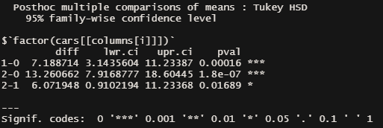

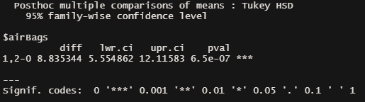

**DriveTrainType:**

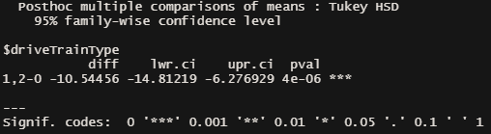

**NumberOfCylinders:**

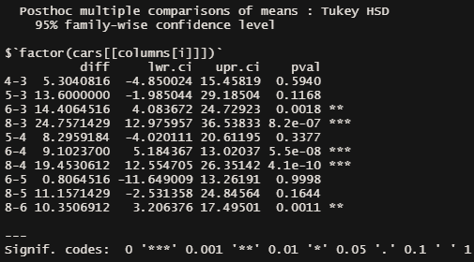

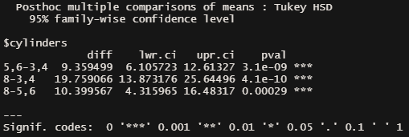

**Manual Trans:**

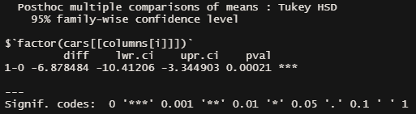

**Passengers:**

